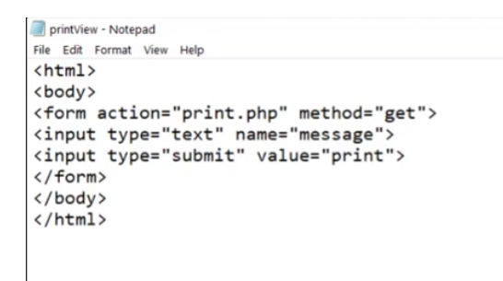

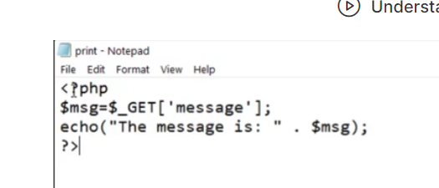

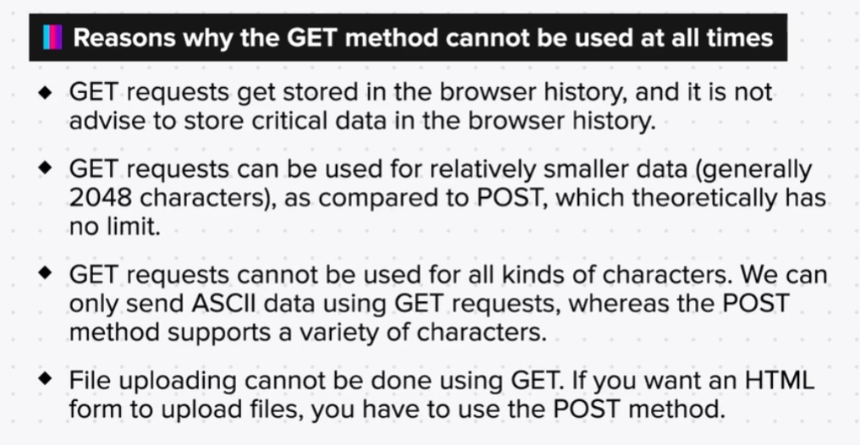

**CALCULATOR**

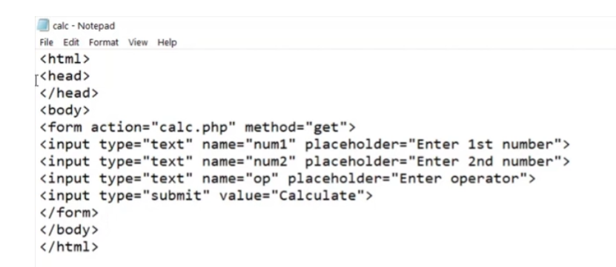

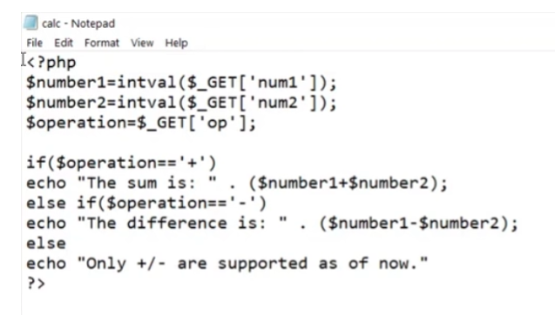

**LOGIN FORM**

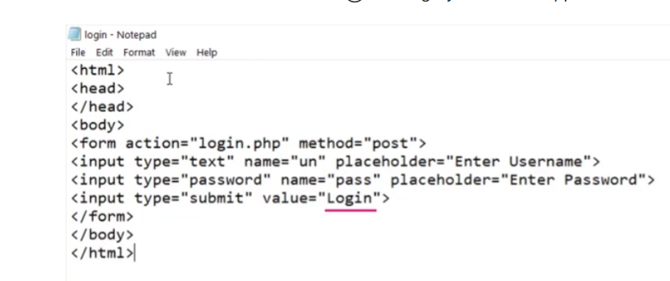

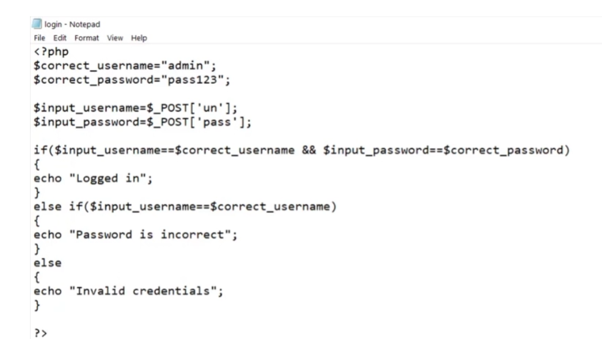

Exercise

Q1. Write a program for a calculator with all other operations like add, subtract, multiply, divide, exponent, concat, modulus, triggered by separate buttons in the form instead of a text field.

Summary

Now that we have come to the end of this topic, you should be able to:

1. Understand input handling in PHP

2. Differentiate between GET and POST methods

3. Take input from the user and generate output

4. Seperate the HTML part from the PHP part of a web application

5. Make a simple web application using PHP